# Python Web Basics Exam – Online Library

*Online Library is an application where we create our own profiles and manage our books. We can open a details page of each book to see the full content.*

## Skeleton

You are provided with all the **html pages**, all the **images** and the **CSS** for the project.

## Database

You will need **2 models**:

* **Profile**
  + **first_name** - Character field with **max length** of **30 characters**
  + **last_name** - Character field with **max length** of **30 characters**
  + **image_url** - URL field
* **Book**
  + **title** - Character field with **max length** of **30 characters**
  + **description** -Text field
  + **image** - URL field
  + **type** - Character field with **max length** of **30 characters**

## Routes

* <http://localhost:8000/> - home page
* <http://localhost:8000/add>/ - add book page
* <http://localhost:8000/edit/:id> - edit book page
* <http://localhost:8000/details/:id> - book details page
* <http://localhost:8000/profile>/ - profile page
* <http://localhost:8000/profile/edit/> - edit profile page
* [http://localhost:8000/profile/delete](http://localhost:8000/profile/delete/)/ - delete profile page

## Pages

### Home Page – 20p

If there is **no profile** created yet:

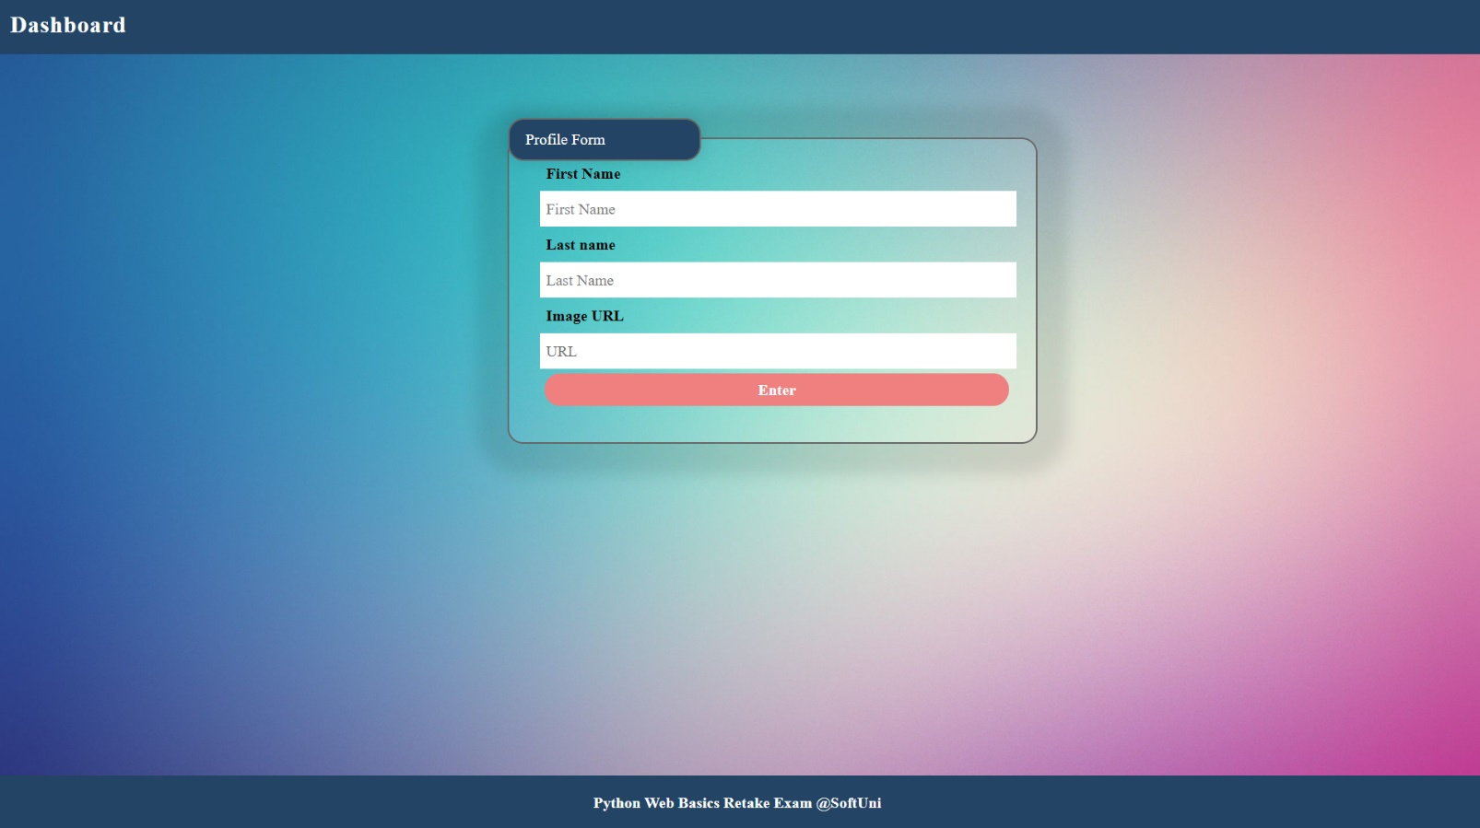

If a profile **has been created** and there are **no books**:

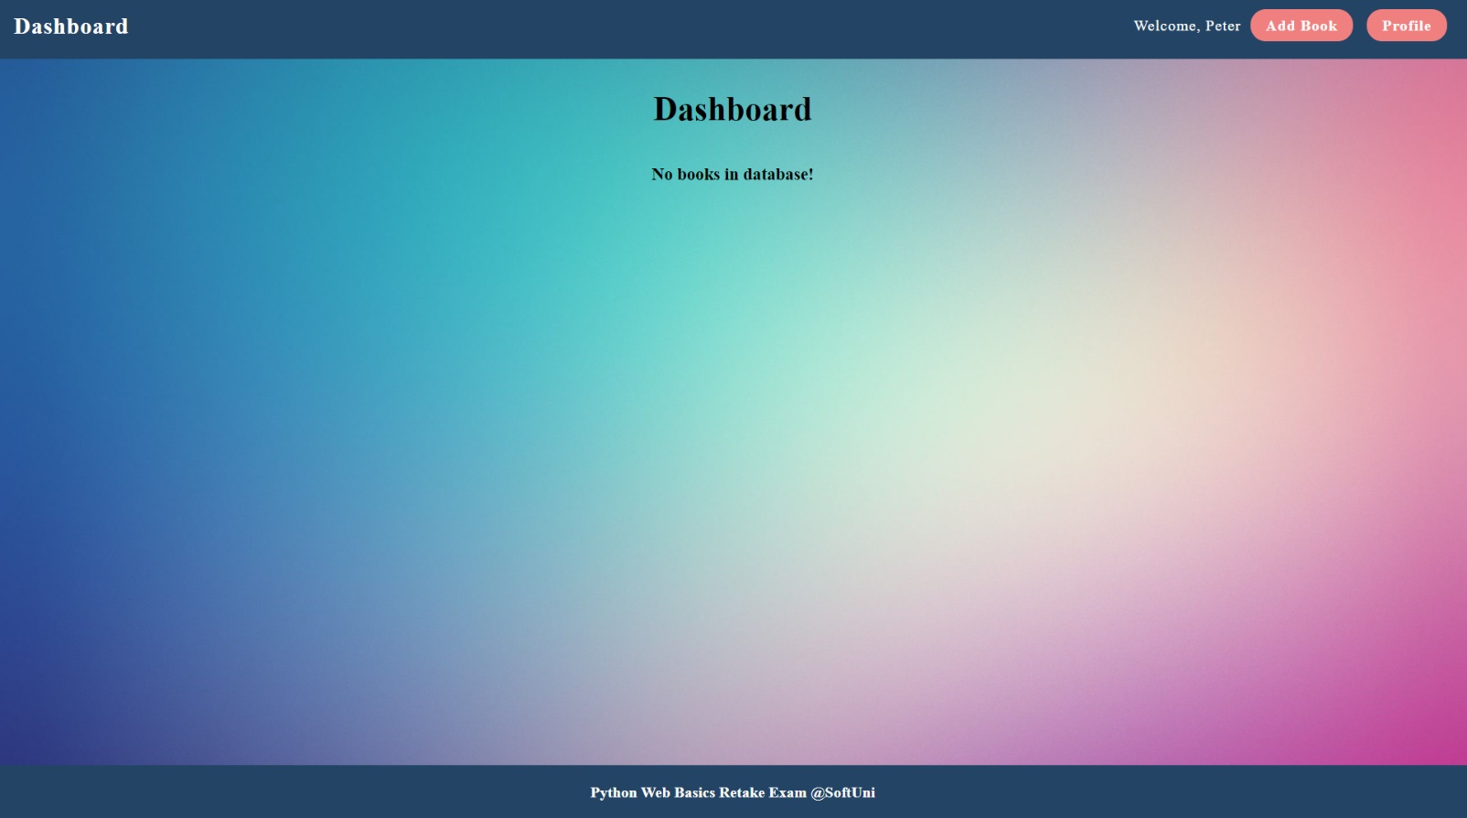

If there is a **profile** and **books.** You should display **maximum of 3 books** on **a single line (the next 3 books should be positioned below, on a second line)**:

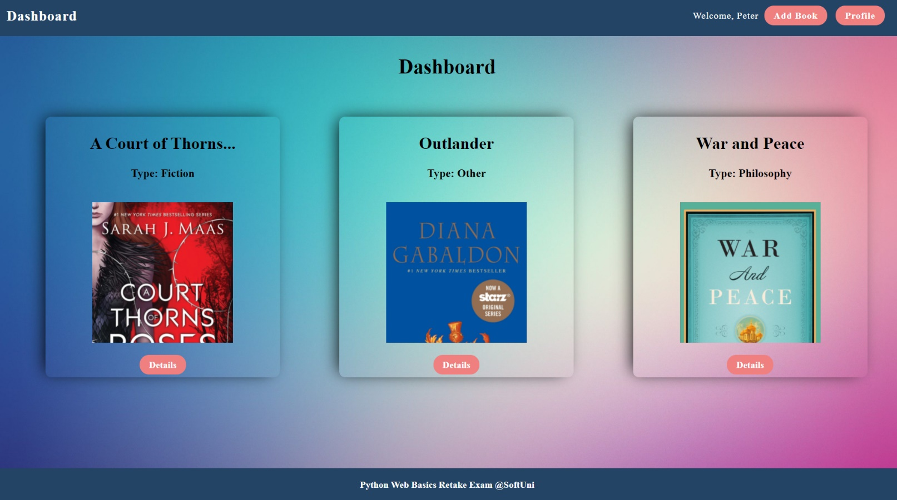

### Add Book Page – 15p

After the button **"Add Book"** is clicked, **add** the book and redirect to home:

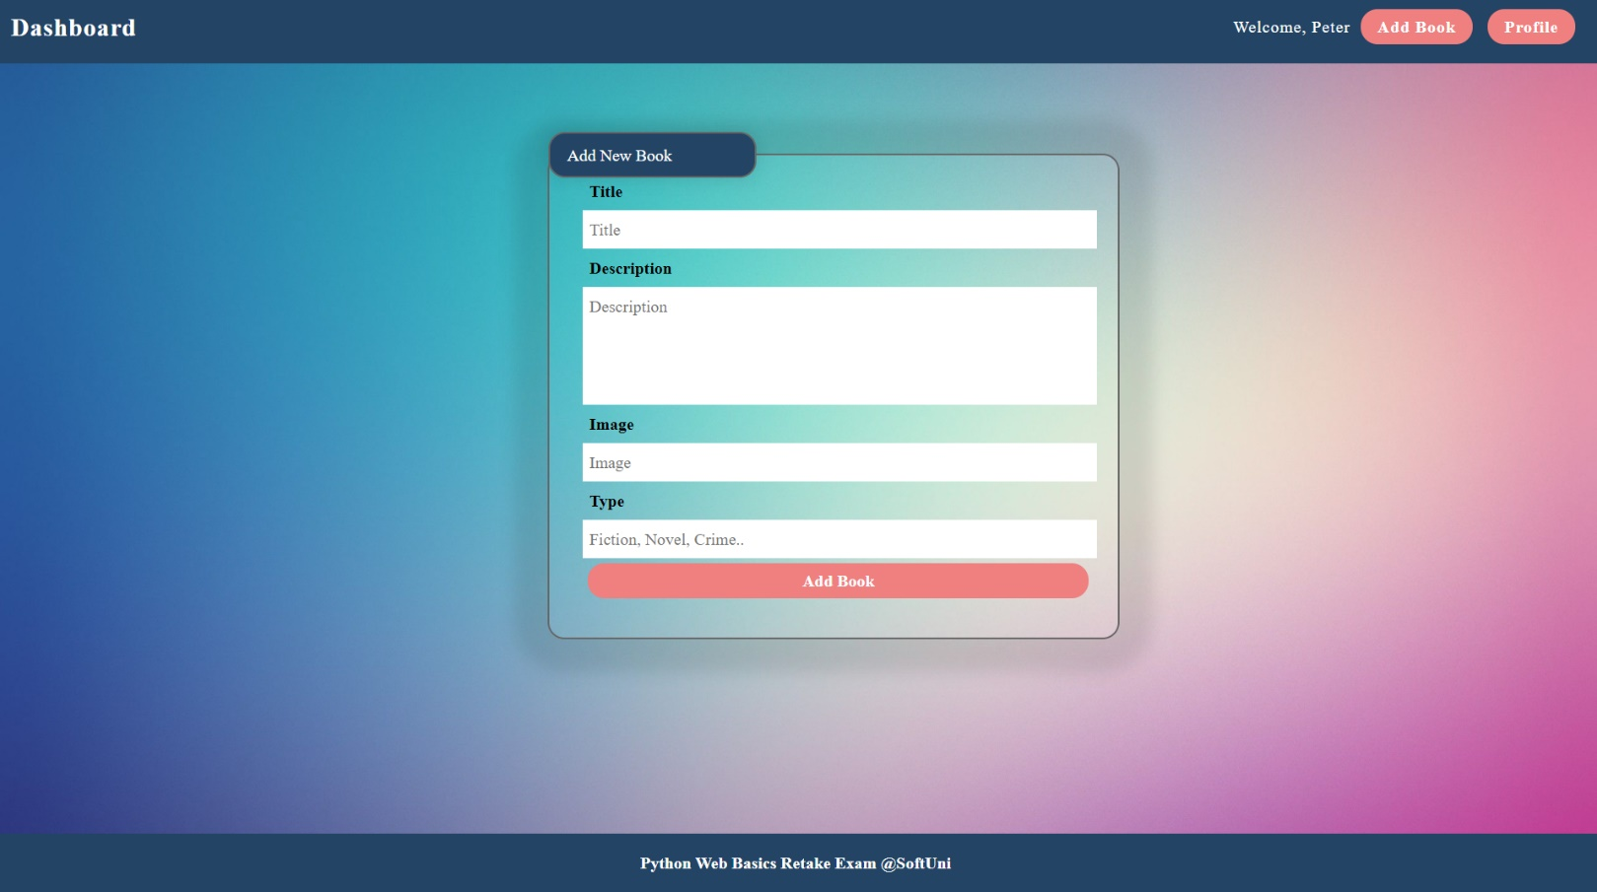

### Book Details Page – 15p

Fill the **needed data**: title, type, image, and description. Also, the view should have two buttons – "**Edit**" and "**Delete**". When the button **"Delete"** is clicked, **delete** the book and **redirect** to home. When the "**Edit**" button is clicked, **redirect** to edit book page.

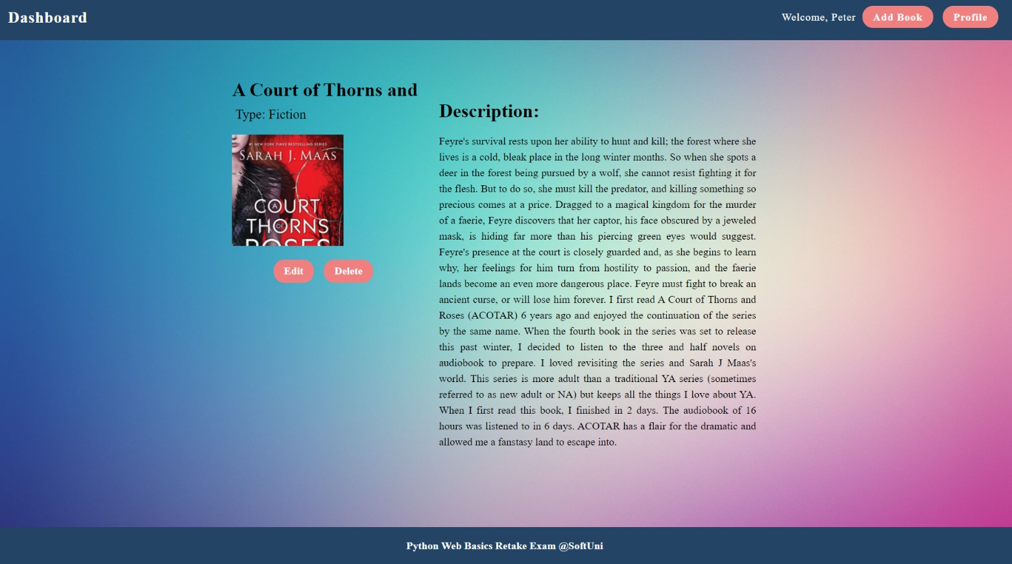

### Edit Book Page – 10p

The form must be **filled** with the **data** of the **book** we want **to edit.** When the button **"Edit"** is clicked, **edit** the book and redirect to home.

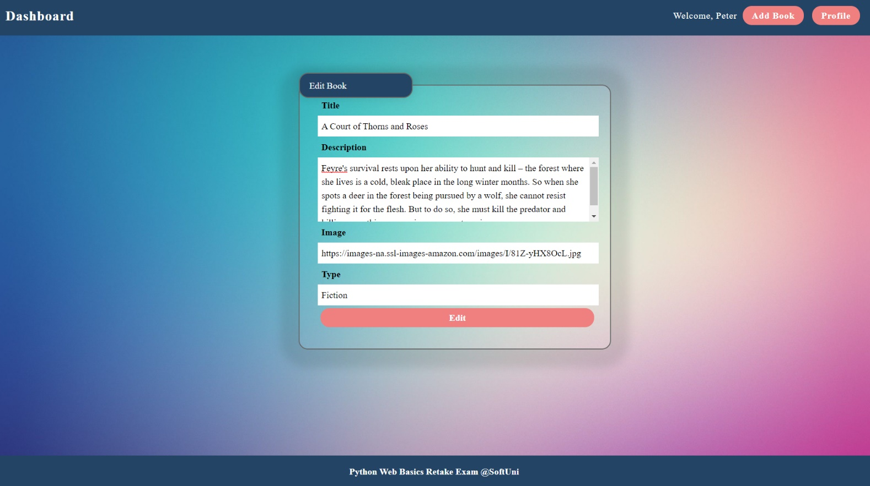

### Profile Page – 15p

Fill the **needed data**: names and picture. Also, the view should have two buttons – "**Edit**" and "**Delete**":

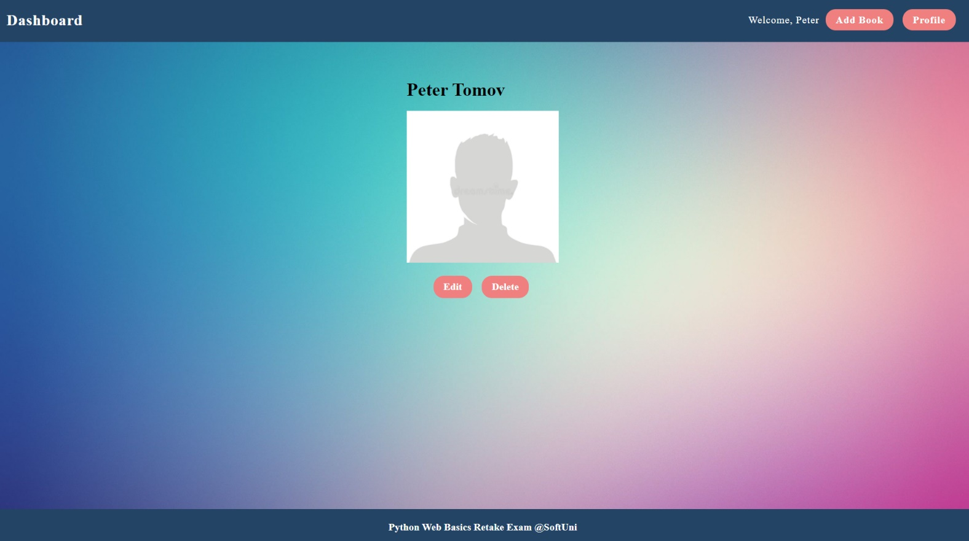

### Edit Profile Page – 5p

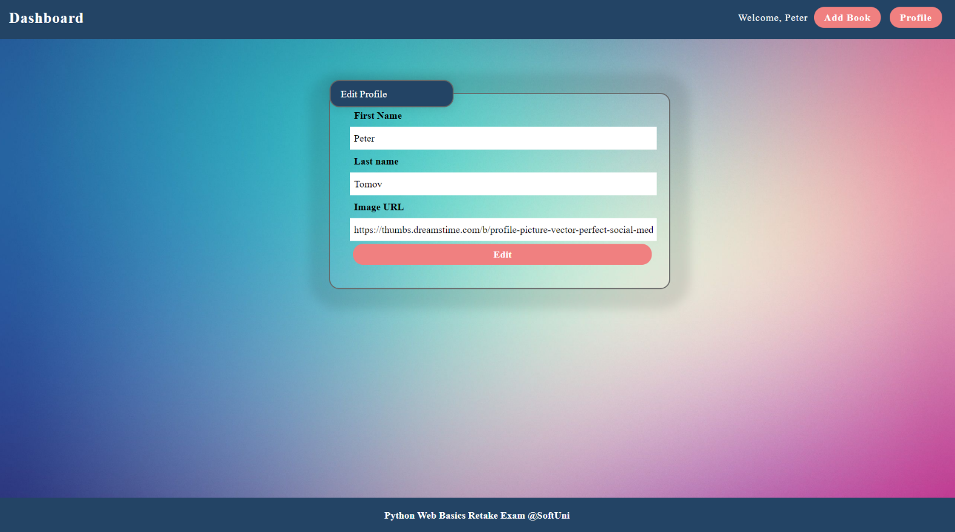The form must be **filled** with the **data** of the created **profile.** When the button **"Edit"** is clicked, **edit** the profile and redirect to profile page.

### Delete Profile Page – 20p

The form must be **filled** with the **data** of the **created profile** and the **fields** should be **disabled**. When the button **"Delete"** is clicked, **delete** the profile, all the books and **redirect** to home.

